**ASSIGNMENT 2**

**COMPLEX QUERY**

1.WRITE A SQL STATEMENT TO DISPLAY THE LOWEST PAID EMPLOYEE'S (NAME , SALARY , DEPARTMENT NAME)

|  |  |  |
| --- | --- | --- |
| **ENAME** | **SAL** | **DNAME** |
| **SMITH** | 800 | RESEARCH |

**QUERY :**

SELECT E.ENAME , E.SAL, D.DNAME FROM EMP E INNER JOIN DEPT D ON E.DEPTNO=D.DEPTNO WHERE E.SAL=(SELECT MIN(SAL) FROM EMP);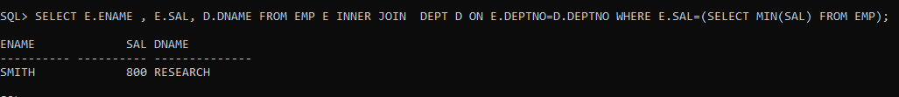

2.LIST MINIMUM SALARY FOR EACH DEPARTMENT

|  |  |
| --- | --- |
| **DEPTNO** | **MIN(SAL)** |
| **10** | 1300 |
| **20** | 800 |
| **30** | 950 |

**QUERY :**

SELECT DEPTNO,MIN(SAL) AS MINSAL FROM EMP GROUP BY DEPTNO ORDER BY DEPTNO;

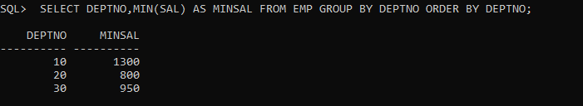

3.WRITE A QUERY BASED ON FOLLOWING RESULT.

|  |  |  |  |  |  |
| --- | --- | --- | --- | --- | --- |
| **EMPNO** | **ENAME** | **JOB** | **SAL** | **DEPTNO** | **DNAME** |
| **7369** | SMITH | CLERK | 800 | 20 | RESEARCH |
| **7900** | JAMES | CLERK | 950 | 30 | SALES |
| **7934** | MILLER | CLERK | 1300 | 10 | ACCOUNTING |

**QUERY :**

SELECT E.EMPNO,E.ENAME,E.JOB,E.SAL MIN_SAL, D.DEPTNO, D.DNAME FROM EMP E , DEPT D WHERE E.DEPTNO=D.DEPTNO AND E.SAL IN (SELECT MIN(SAL) FROM EMP GROUP BY DEPTNO) ORDER BY SAL;

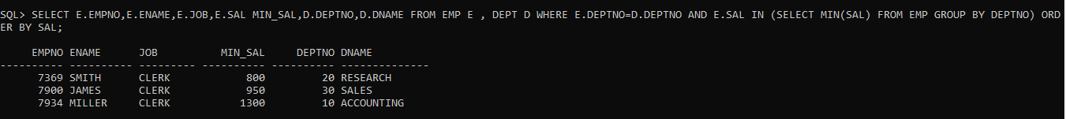

|  |  |  |  |  |  |  |
| --- | --- | --- | --- | --- | --- | --- |
| **EMPNO** | **ENAME** | **JOB** | **MGR** | **HIREDATE** | **SAL** | **DEPTNO** |
| **7369** | SMITH | CLERK | 7902 | 17-Dec-00 | 800 | 20 |
| **7566** | JONES | MANAGER | 7839 | 02-Apr-01 | 2975 | 20 |
| **7788** | SCOTT | ANALYST | 7566 | 19-Apr-07 | 3000 | 20 |
| **7876** | ADAMS | CLERK | 7788 | 23-May-07 | 1100 | 20 |
| **7902** | FORD | ANALYST | 7566 | 03-Dec-01 | 3000 | 20 |

4.LIST ALL THE EMPLOYEES WHO ARE WORKING IN FORD’S DEPARTMENT.

**QUERY :**

SELECT * FROM EMP WHERE DEPTNO=(SELECT DEPTNO FROM EMP WHERE ENAME='FORD');

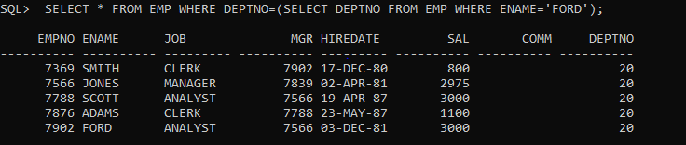

5.LIST ALL EMPLOYEE WHO ARE WORKING IN WARD'S DEPARTMENT AND

|  |  |  |  |  |  |  |
| --- | --- | --- | --- | --- | --- | --- |
| **EMPNO** | **ENAME** | **JOB** | **MGR** | **HIREDATE** | **SAL** | **DEPTNO** |
| **7369** | SMITH | CLERK | 7902 | 17-Dec-00 | 800 | 20 |
| **7566** | JONES | MANAGER | 7839 | 02-Apr-01 | 2975 | 20 |
| **7788** | SCOTT | ANALYST | 7566 | 19-Apr-07 | 3000 | 20 |

EARNING MORE THEN MARTIN

**QUERY :**

SELECT * FROM EMP WHERE DEPTNO=(SELECT DEPTNO FROM EMP WHERE ENAME='WARD')AND SAL>(SELECT SAL FROM EMP WHERE ENAME = 'MARTIN');

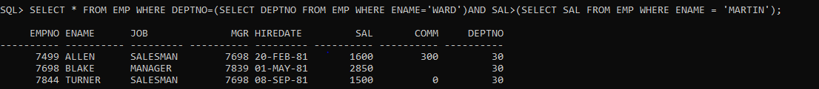

6.DISPLAY EMPLOYEE NUMBER, NAME,DEPT NUMBER, DEPT NAME, AND LOCATION

|  |  |  |  |  |
| --- | --- | --- | --- | --- |
| **EMPNO** | **ENAME** | **DEPTNO** | **DNAME** | **LOC** |
| **7369** | SMITH | 20 | RESEARCH | DALLAS |
| **7499** | ALLEN | 30 | SALES | CHICAGO |
| **7521** | WARD | 30 | SALES | CHICAGO |
| **7566** | JONES | 20 | RESEARCH | DALLAS |
| **7654** | MARTIN | 30 | SALES | CHICAGO |
| **7698** | BLAKE | 30 | SALES | CHICAGO |
| **7782** | CLARK | 10 | ACCOUNTING | NEW YORK |
| **7788** | SCOTT | 20 | RESEARCH | DALLAS |
| **7839** | KING | 10 | ACCOUNTING | NEW YORK |
| **7844** | TURNER | 30 | SALES | CHICAGO |
| **7876** | ADAMS | 20 | RESEARCH | DALLAS |
| **7900** | JAMES | 30 | SALES | CHICAGO |
| **7902** | FORD | 20 | RESEARCH | DALLAS |
| **7934** | MILLER | 10 | ACCOUNTING | NEW YORK |

**QUERY :**

SELECT E.EMPNO,E.ENAME ,E.DEPTNO, D.DNAME,D.LOC FROM EMP E INNER JOIN DEPT D ON E.DEPTNO=D.DEPTNO;

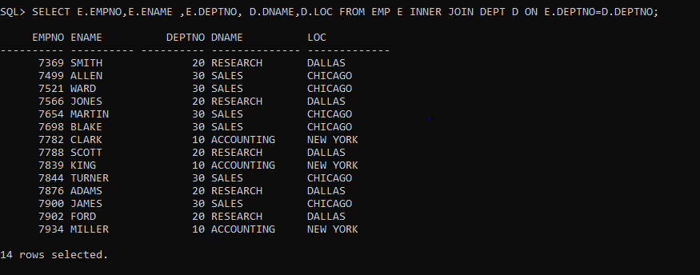

7.DISPLAY THE FOLLOWING RESULT

|  |  |  |
| --- | --- | --- |
| **DEPTNO** | **DNAME** | **ENAME** |
| **10** | ACCOUNTING | CLARK |
| **10** | ACCOUNTING | KING |
| **10** | ACCOUNTING | MILLER |
| **20** | RESEARCH | JONES |
| **20** | RESEARCH | FORD |
| **20** | RESEARCH | ADAMS |
| **20** | RESEARCH | SMITH |
| **20** | RESEARCH | SCOTT |
| **30** | SALES | WARD |
| **30** | SALES | TURNER |
| **30** | SALES | ALLEN |
| **30** | SALES | JAMES |
| **30** | SALES | BLAKE |
| **30** | SALES | MARTIN |

**QUERY :**

SELECT D.DEPTNO,D.DNAME, E.ENAME FROM EMP E, DEPT D WHERE E.DEPTNO=D.DEPTNO ORDER BY DEPTNO;

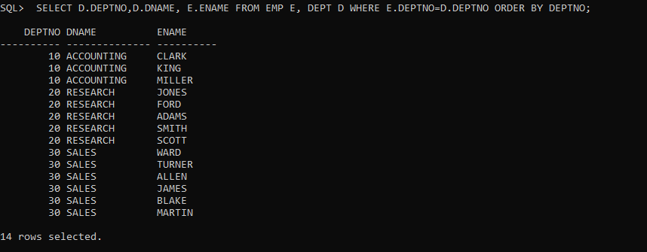

8.LIST ALL THE EMPLOYEE WHO ARE WORKING IN NEW YORK

|  |  |  |  |
| --- | --- | --- | --- |
| **ENAME** | **DEPTNO** | **DNAME** | **LOC** |
| **CLARK** | 10 | ACCOUNTING | NEW YORK |
| **KING** | 10 | ACCOUNTING | NEW YORK |
| **MILLER** | 10 | ACCOUNTING | NEW YORK |

**QUERY :**

SELECT E.ENAME, D.* FROM EMP E, DEPT D WHERE E.DEPTNO=D.DEPTNO AND D.LOC='NEW YORK';

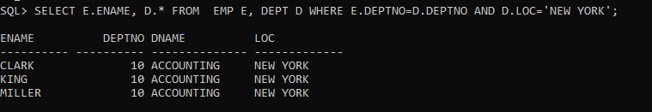

9.WRITE A SQL STATEMENT TO DISPLAY THE LOWEST PAID EMPLOYEE'S (NAME , SALARY , DEPARTMENT NAME) IN THE RESPECTIVE DEPARTMENT.

|  |  |  |
| --- | --- | --- |
| **ENAME** | **MIN(SAL)** | **DNAME** |
| **SMITH** | 800 | RESEARCH |
| **JAMES** | 950 | SALES |
| **MILLER** | 1300 | ACCOUNTING |

**QUERY :**

SELECT E.ENAME,E.SAL MIN_SAL,D.DNAME FROM EMP E,DEPT D WHERE E.DEPTNO=D.DEPTNO AND E.SAL IN (SELECT MIN(SAL) FROM EMP GROUP BY DEPTNO)ORDER BY E.SAL;

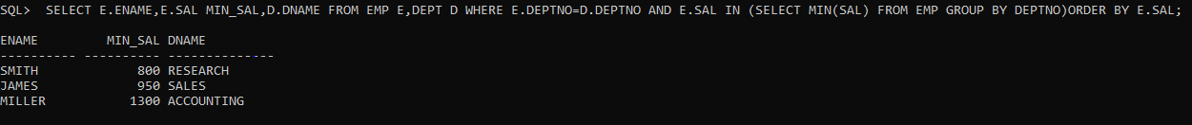

10.WRITE A SQL STATEMENT TO DISPLAY THE HIGHEST PAID EMPLOYEE'S (NAME, JOB, MANAGER NAME, SALARY AND DEPARTMENT NAME AND DEPARTMENT NO.) IN THE RESPECTIVE DEPARTMENT.

|  |  |  |  |  |
| --- | --- | --- | --- | --- |
| **EMPNO** | **JOB** | **MGR** | **MAX(SAL)** | **DNAME** |
| **7698** | MANAGER | 7839 | 2850 | SALES |
| **7788** | ANALYST | 7566 | 3000 | RESEARCH |
| **7839** | PRESIDENT |  | 5000 | ACCOUNTING |
| **7902** | ANALYST | 7566 | 3000 | RESEARCH |

**QUERY :**

SELECT E.EMPNO,E.JOB,E.MGR,E.SAL,D.DNAME FROM EMP E,DEPT D WHERE E.DEPTNO=D.DEPTNO AND E.SAL IN (SELECT MAX (SAL) FROM EMP GROUP BY DEPTNO)ORDER BY EMPNO;

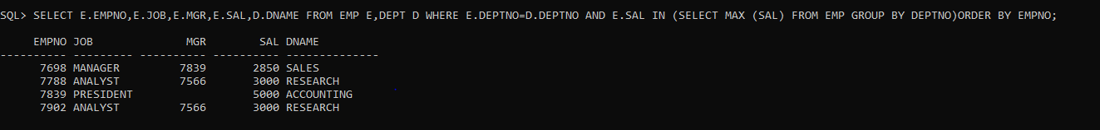

11.WRITE A SQL STATEMENT TO DISPLAY THE EMPLOYEE NAME (BOSS) AND NUMBER OF EMPLOYEE (SUBORDINATES) DIRECTLY REPORTING TO HIM?

|  |  |
| --- | --- |
| **BOSS** | **SUBORDINATES** |
| **JONES** | 2 |
| **FORD** | 1 |
| **CLARK** | 1 |
| **SCOTT** | 1 |
| **BLAKE** | 5 |
| **KING** | 3 |

**QUERY :**

SELECT E1.ENAME BOSS ,COUNT (E2.ENAME) SUBORDINATES FROM EMP E1, EMP E2 WHERE E1.EMPNO=E2.MGR GROUP BY E1.ENAME;

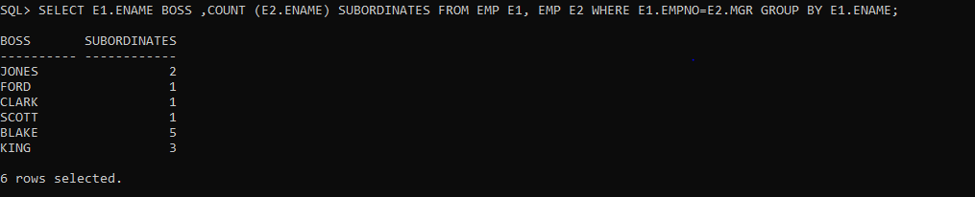

12.DISPLAY THE NAMES, DESIGNATION AND SALARIES OF ALL EMPLOYEES WHO HAVE MANAGER ALONG WITH MANAGER'S NAME, DESIGNATION AND MANAGER'S SALARY.(SELF-JOIN)

**QUERY :**

SELECT E1.ENAME,E1.JOB,E1.SAL,E2.ENAME,E2.JOB,E2.SAL FROM EMP E1,EMP E2 WHERE E1.MGR=E2.EMPNO;

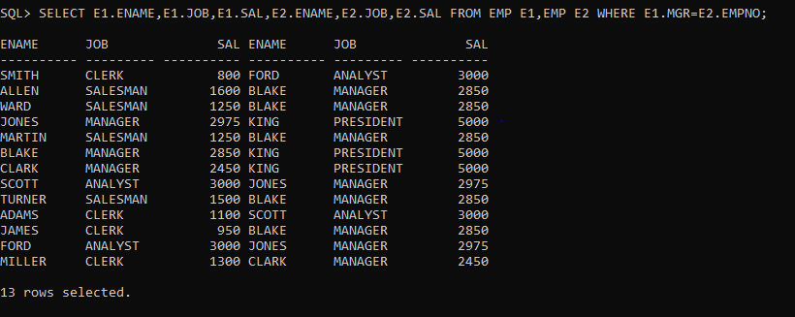

13.Create the following tables:

ORDER: {Id, OrderDate, OrderNumber}

ORDER_ITEM: {Id, OrderId, ProductId, UnitPrice, Quantity}

PRODUCT: {Id, ProductName}

Write a query to display the following output sorted by order no:

|  |  |  |  |  |
| --- | --- | --- | --- | --- |
| **ORDER_NO** | **ORDER_DATE** | **PRODUCT_NAME** | **QUANTITY** | **UNIT_PRICE** |
| **7369** | 7/4/2012 12:00:00 AM | EASY-TRADING | 800 | 20 |
| **7900** | 2/10/2011 12:00:00 AM | BANK-ANYWHERE | 950 | 30 |
| **7934** | 9/23/2015 12:00:00 AM | TRIP-MANAGER | 1300 | 10 |

TO CREATE TABLE

**QUERY :**

CREATE TABLE ORDER1(ID NUMBER(5),ORDERDATE DATE,ORDERNUMBER NUMBER(10),PRIMARY KEY (ID));

CREATE TABLE ORDER_ITEM(ID NUMBER(5),PRODID NUMBER (5),UNITPRICE NUMBER(5),QTY NUMBER(6));

CREATE TABLE PRODUCT(ID NUMBER(5), PRODNAME VARCHAR(10));

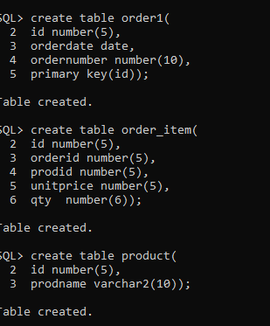

TO DISPLAY DATA

**QUERY :**

SELECT * FROM ORDER1;

SELECT * FROM ORDERITEM;

SELECT * FROM PRODUCT;

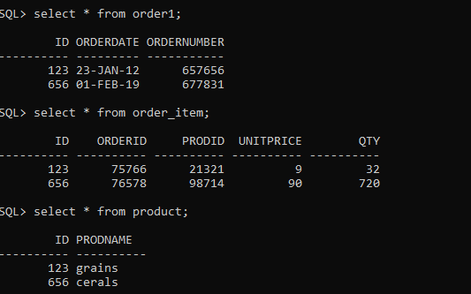

**QUERY :**

SELECT ORDER1.ID,ORDER1.ORDERDATE,PRODUCT.PRODNAME,ORDER_ITEM.QTY, ORDER_ITEM.UNITPRICE FROM ORDER1 INNER JOIN (ORDER_ITEM INNER JOIN PRODUCT ON PRODUCT.ID = ORDER_ITEM.ID) ON ORDER1.ID= ORDER_ITEM.ID;



14. Find the 2nd minimum salary of the employee.

**QUERY :**

SELECT MIN(SAL) "2ND MIN" FROM EMP WHERE SAL> (SELECT MIN (SAL) FROM EMP);

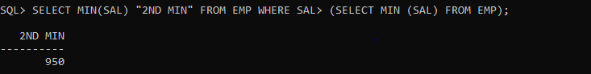

15.Find the max 3 salaries from employee table.

**QUERY :**

SELECT SAL FROM (SELECT ROWNUM SLNO,SAL FROM (SELECT DISTINCT SAL FROM EMP ORDER BY SAL DESC)) WHERE SLNO<4;

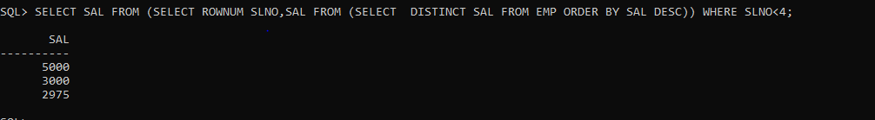

16. Display common records from emp_1 & emp_2 tables. (Use INTERSECT)

**QUERY :**

SELECT E1.* FROM EMP E1 INTERSECT SELECT E2.* FROM EMP E2;

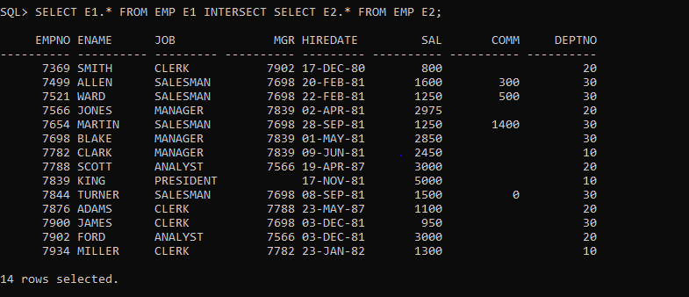

17. Display department no wise total salary where more than 2 employees exist in a department.

**QUERY :**

SELECT DEPTNO,SUM(SAL) FROM EMP GROUP BY DEPTNO HAVING COUNT (*)>2;

